Online Gas Booking App

Project Setup:
1. Navigate to - https://github.com/Ayeshaq09/Unified-mentor-projects You will see all 8 projects.
2. To get the projects onto your system: click on "Code" button and copy the link - https://github.com/Ayeshaq09/Unified-mentor-projects.git
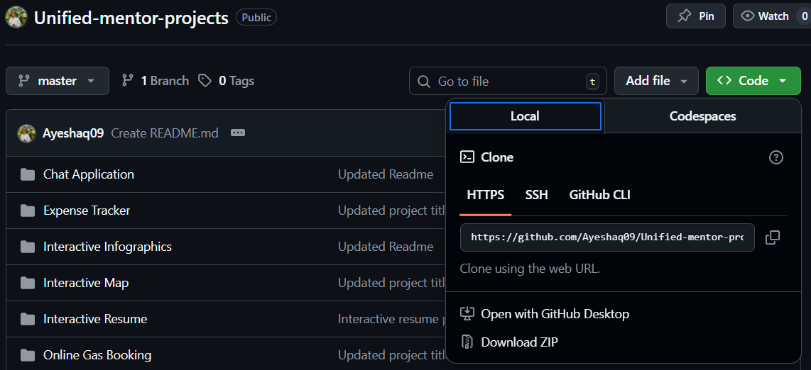
3. Open git bash and run the following command:
git clone https://github.com/Ayeshaq09/Unified-mentor-projects.git
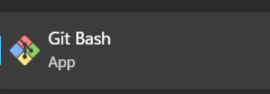
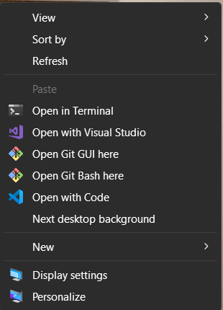
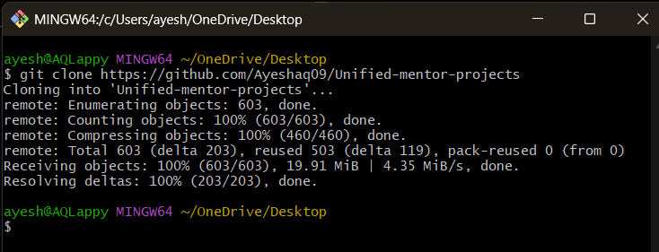
4. Once cloning is done, you get all the 8 projects onto your system.

About the project:
This project allows users to book cylinders and the admin to approve or cancel the user books and it contains customers module, booking module, notice module and settings module.

Features
This application supports two types of users:
1.Admin
- Has access to manage customers, bookings, notices, and application settings.
- Can approve or reject booking requests.
- Can add important notices for users.

2.User (Client)
- Can add and manage their own cylinder bookings.
- Can view booking history and active notices posted by the admin.

The app is mobile-responsive and is user-friendly.

Technologies Used
- HTML5, CSS3, JavaScript, Reactjs
- Nodejs for backend
- Firebase for data storage
- react-toastify for notifications

Online Gas Booking project setup:
- Open the folder in vscode and in terminal run – cd frontend
npm install

Then do same in backend folder
cd..
cd backend
npm install

- Then in frontend folder add “.env.local” file with following content. (Double click on the below code snippet, a new document will open with code and then copy the content and paste it in a file named “.env.local” in frontend folder. This file is important and such files cannot be added in github as they contain confidential data in it.)
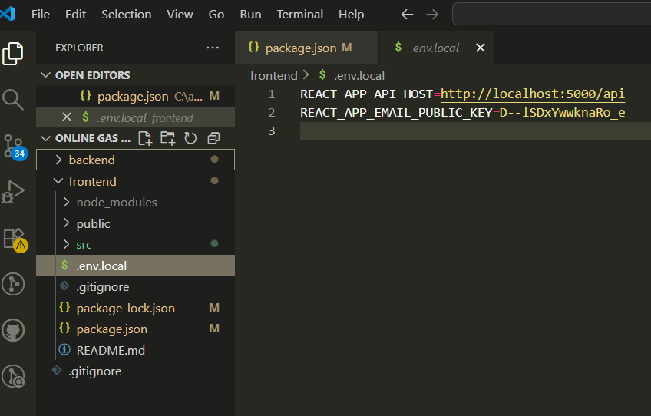

- Then add new file named – “serviceAccountKey.json” file in backend folder and add the following content in it. (Double click on the below code snippet, a new document will open with code and then copy the content and paste it in a file named “serviceAccountKey.json” in backend folder. This file is important for the firebase connection and such files cannot be added in github as they contain confidential data in it.)
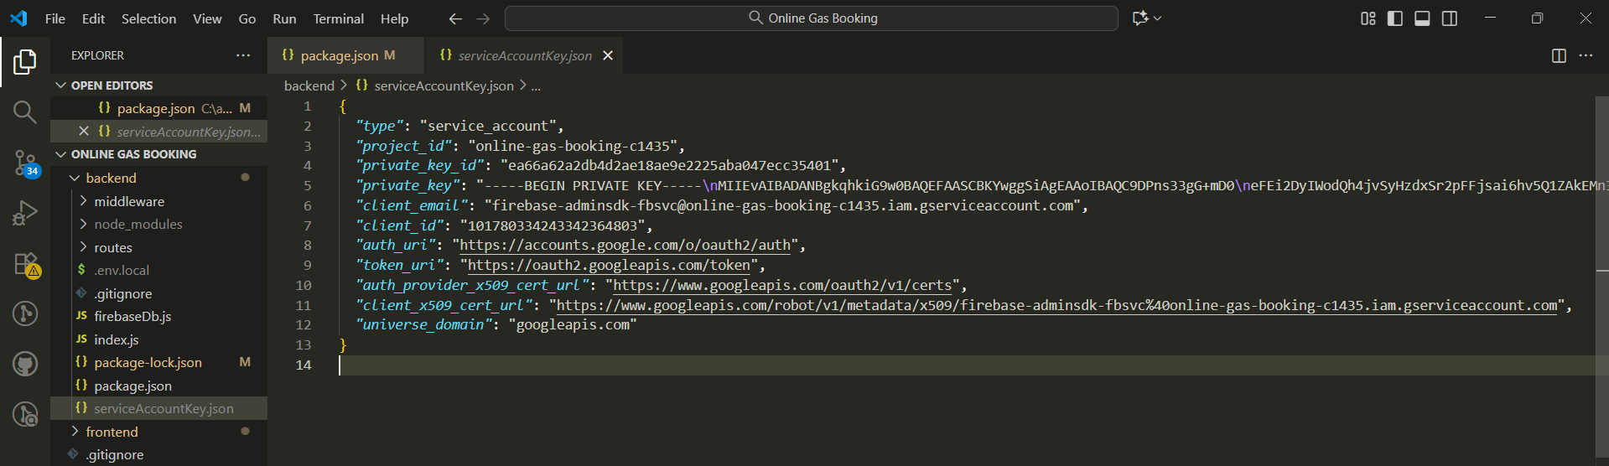
- Then in backend folder add “.env.local” file with following content. (Double click on the below code snippet, a new document will open with code and then copy the content and paste it in a file named “.env.local” in backend folder. This file is important and such files cannot be added in github as they contain confidential data in it.)
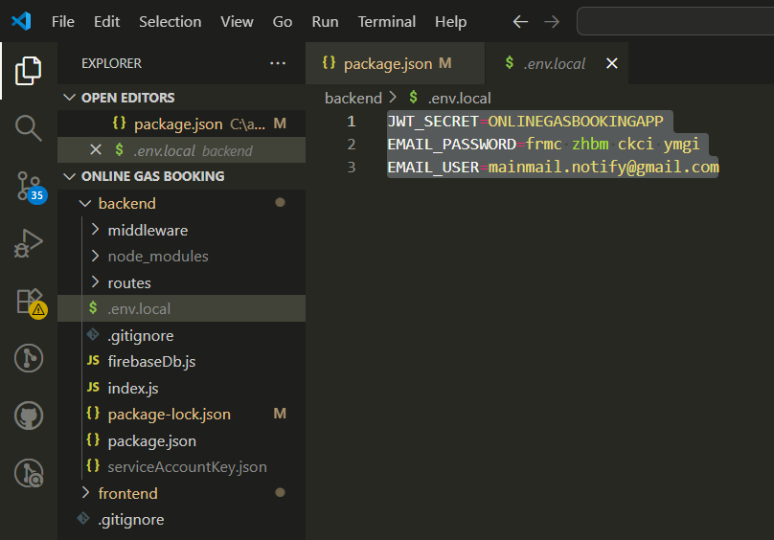

- Then run – cd..
cd frontend
npm run both
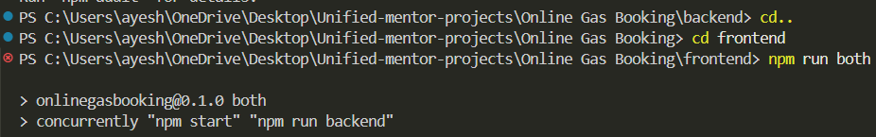

Functionality of the project:
1. The application first displays the login page and if the user is new then he/she can register using register page.
-Once registered the user can login.

Login page:
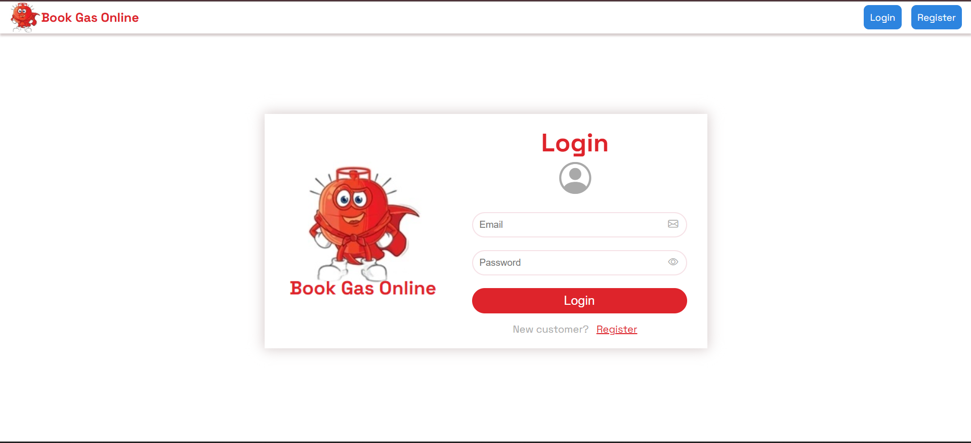

Register page:
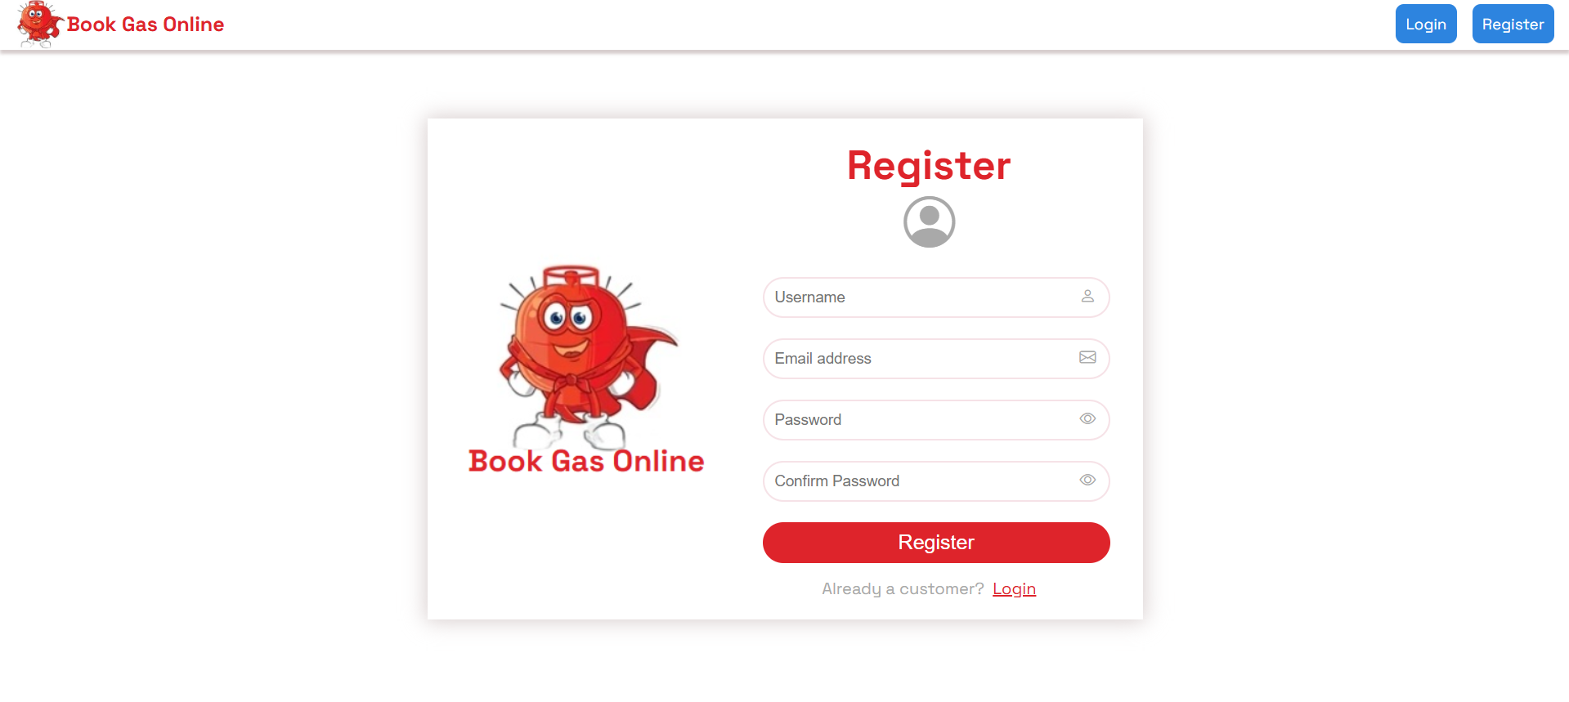

Admin credentials:
email - mainmail.notify@gmail.com
password - mainmail.notify

User credentials:
*Register as a new user*
For example – I have just registered the user ‘Ayesha’.
Once registered, then login.
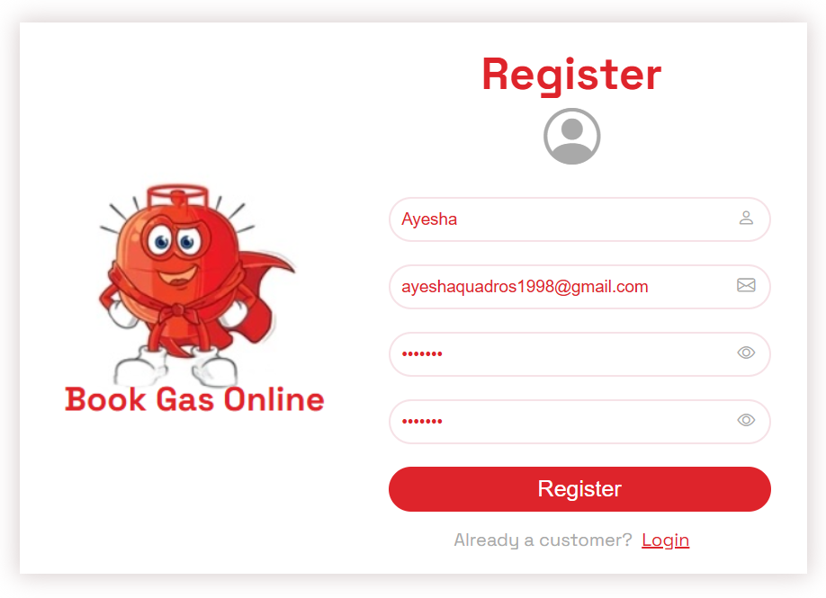

The admin contains:
1. Manage Customers
- All the registered/added customers are displayed here.
- Admin can edit the customer details or delete the customer.
- Customer details contain - name, email, total barrels assigned (12 for a year),
- start date (date when user was added), end date (that's the end date for the total assigned barrels).
- If Admin deletes a user, then all the linked bookings are also deleted from the firebase.
- Admin can also search customers based on name.
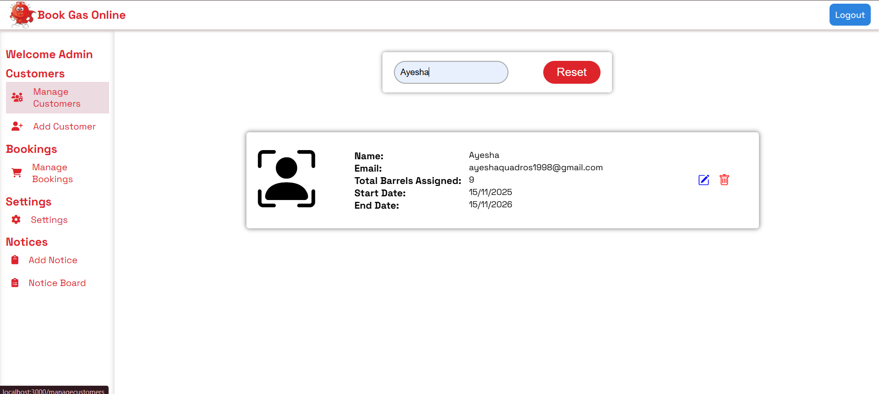

2. Add Customer
- Admin can add new customer
- The form contains name, email, password.
- Once the user is added, 12 total barrels will be assigned to the user.
- Then, user can login and add bookings.
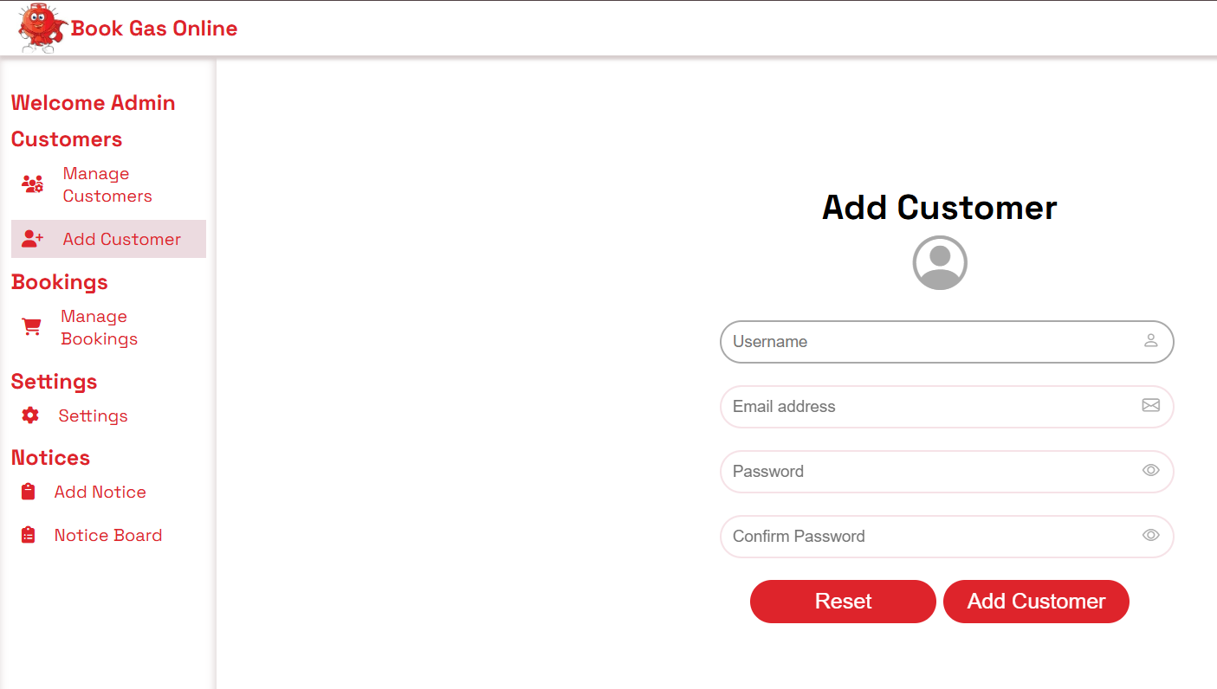

3. Manage Bookings
-All the user bookings are displayed here.
-Admin can approve or cancel the bookings.
-Booking details contain - name, email, address, mobile number, Number of cylinders booked by user, status (Pending, Approved, Cancelled), booking date.
-Admin can also search bookings based on name and status.
-When admin approves or cancels the booking, the user receives a mail from the admin email - mainmail.notify@gmail.com (During registration as a new user, please enter valid email so that you receive mails when admin approves or cancels your booking).

Admin approved one booking and cancelled one booking of user ‘Ayesha’
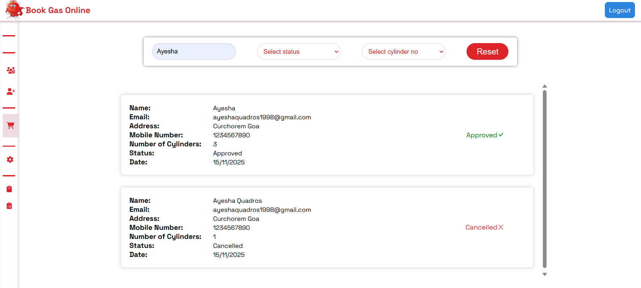

User ‘Ayesha’ received mails regarding the booking status from admin – mainmail.notify@gmail.com .
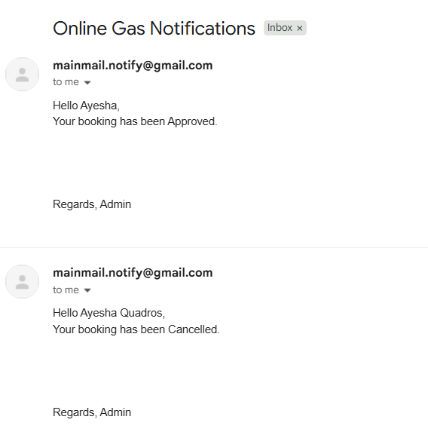

4. Settings
-It contains email settings - admin name, email, subject
Cylinder settings - maximum number of cylinders that a user can book during each booking.
-Admin can change/update - name, subject and max cylinder number.
-Admin email cannot be changed.
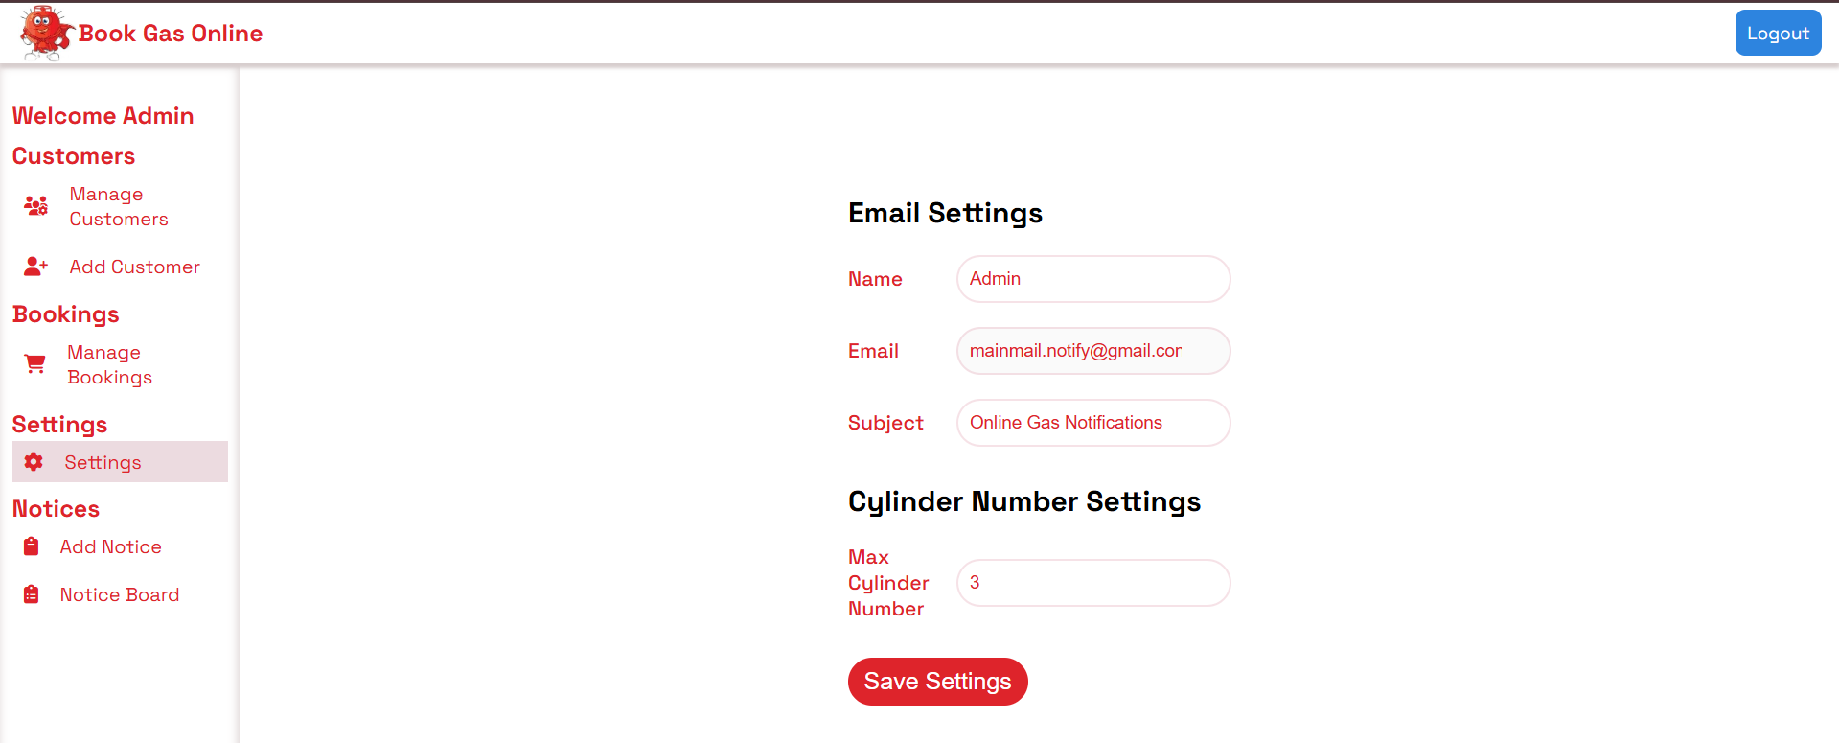

5. Add Notice
-Admin can add notice for users.
-The form contains - title, message, message severity (Critical, Warning, General), duration (when duration expires the notice will not be displayed to the user).
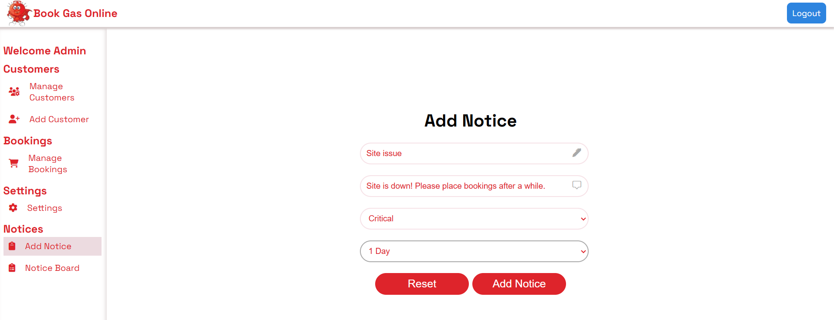

6. Notice Board
-All valid notices are displayed here.
- green- General notice, red – Critical notice, yellow – Warning notice.
-Admin can edit and delete notices.
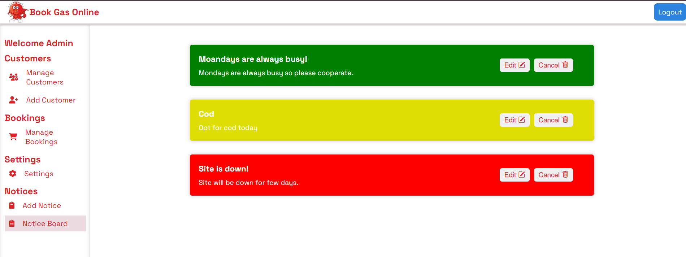

The user contains:
1. Booking History
-It displays all the booking history of the user.
-The booking details contain - name, email, address, mobile number, no. of cylinders booked, status, date of booking.
-If the admin, cancels or approves the booking, the status here changes accordingly.
-When booking is placed, for about 3 days user can edit/delete the booking details if the booking status is pending.
-User can also search the bookings based on no. of cylinders and status.

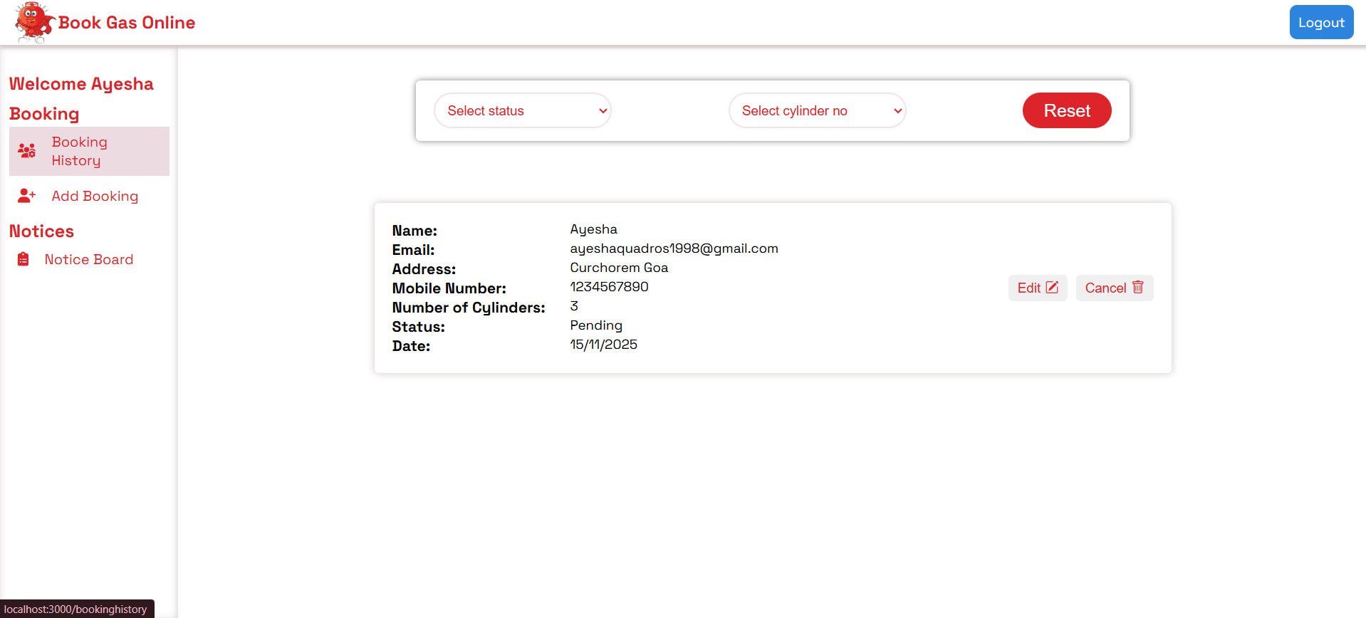
Below the status is ‘Approved’ and ‘Cancelled’ as the admin approved and cancelled the bookings respectively.
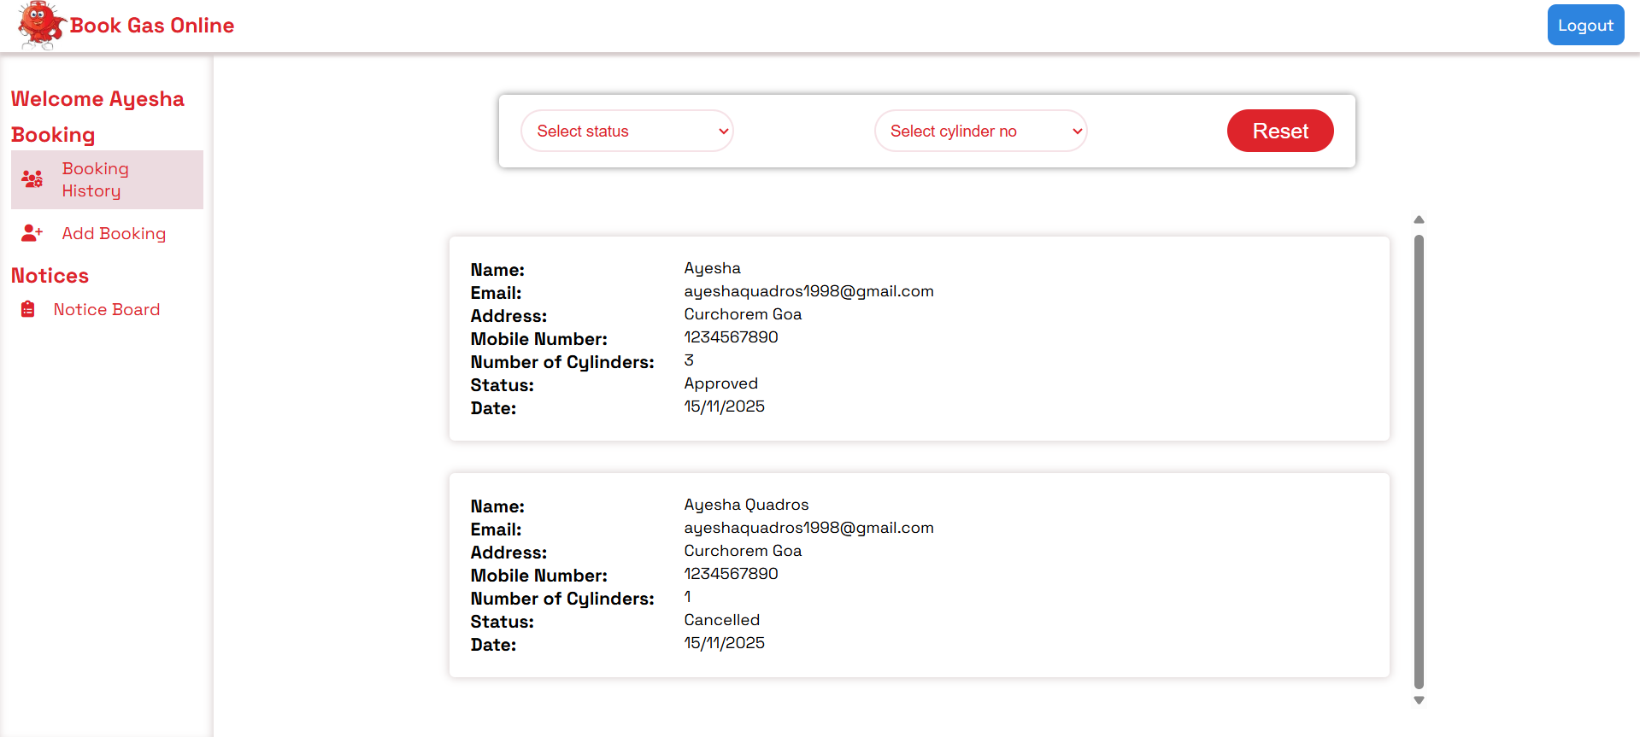

2. Add booking
-User can add booking.
-The form contains name, email, address, mobile number, number of cylinders.
-When booking is placed, the number of booked cylinders is deducted from the total barrels count (12).
-If the booking is cancelled by admin or deleted by the user, then the number of cylinders booked are added back to the total barrels.
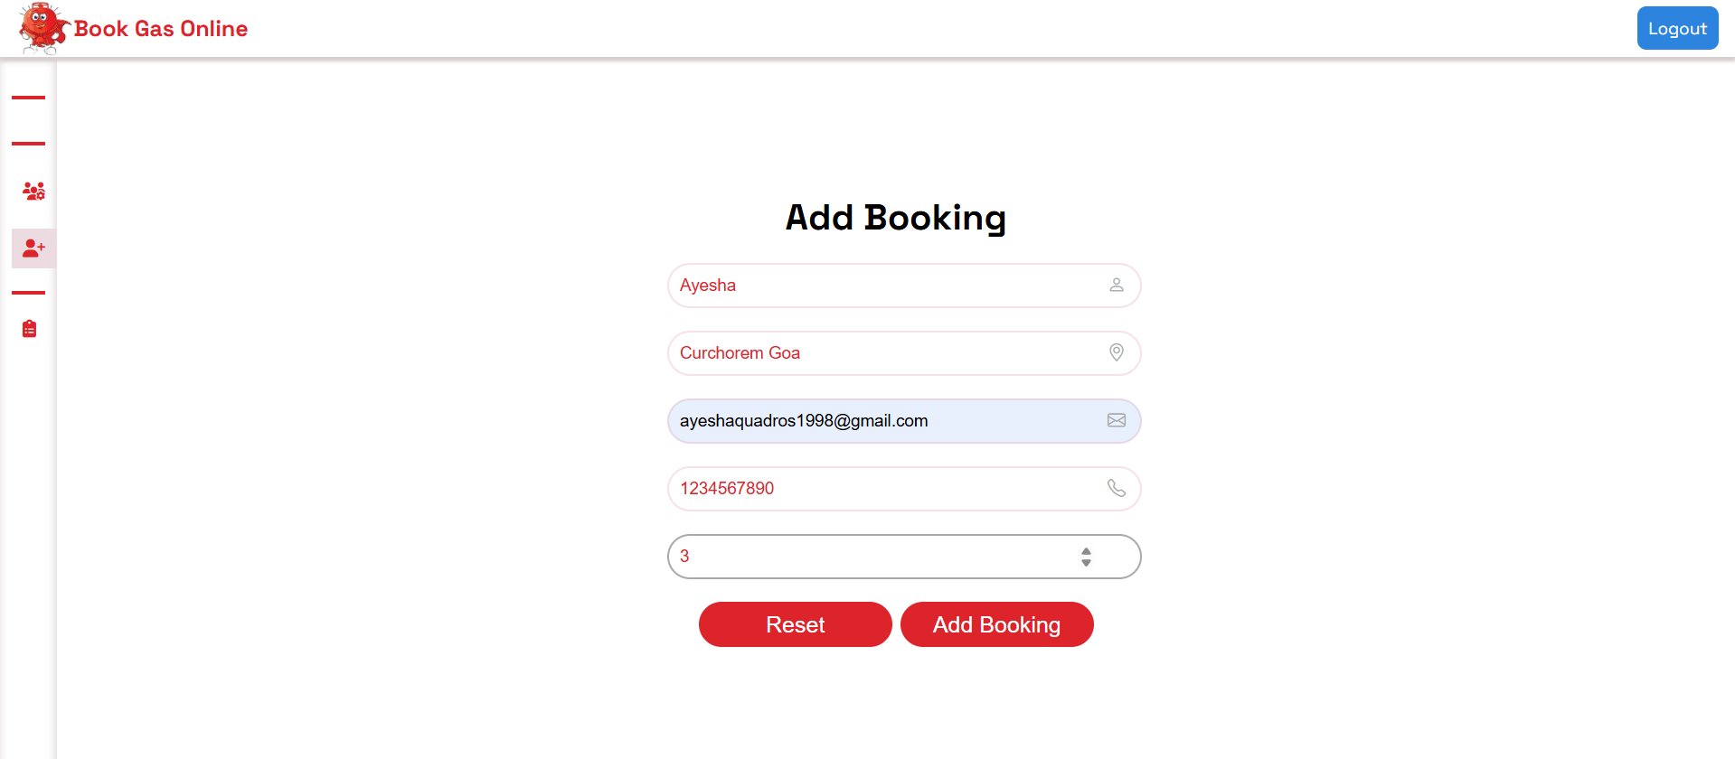

3. Notice Board
-It displays all the valid notices here that are added by admin.
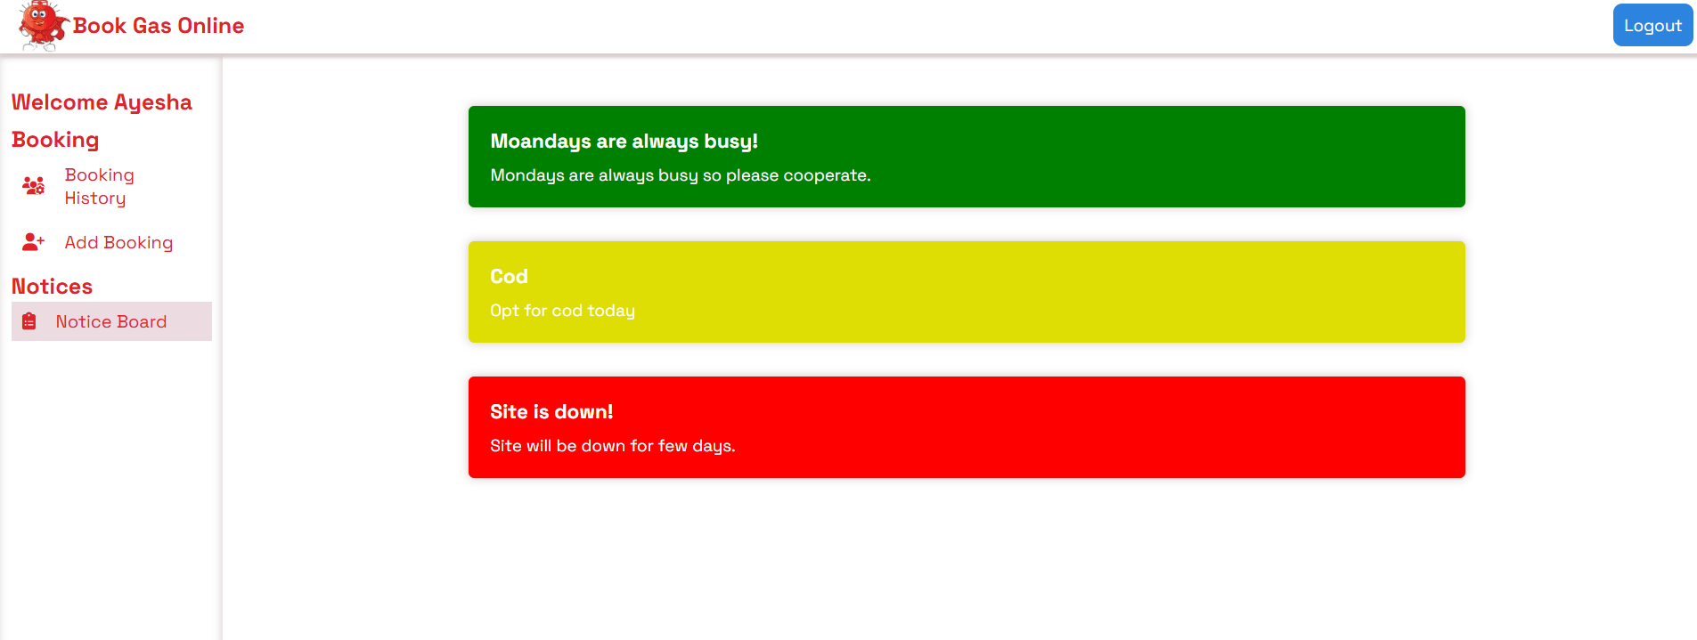

-The user or the admin can then logout.

Resize the screen to check the responsiveness of the application.

